**Global Blood Therapeutics (GBT)**

MARKET DATA

|  |  |
| --- | --- |
| Rating | **BUY** |
| Price (8/11/2019) | 48.79 |
| Target Price Range | 75-150 |
| 52-Week Price Range | 30.5-64.9 |
| Market Cap. (US$m) | 2930 |
|  |  |

***\*****target price is for 6 months*

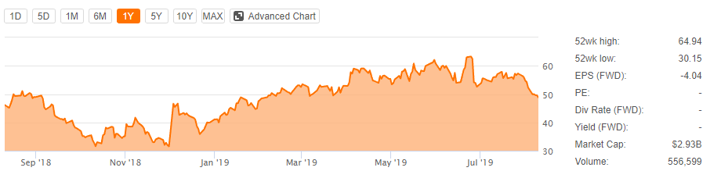

2

1

1. On Dec3 19, the company announced **POSTIVE** **[results](https://seekingalpha.com/news/3414001-global-bloods-voxelotor-shows-positive-action-late-stage-sickle-cell-study-shares-56-percent)** from a critical Phase 3(HOPE Study).This caused the shares to rocket up almost 50% on the day. Meanwhile GBT is preparing the NDA having more clarity on its confirmatory study design before end Q1 2019, also complete the Licensed Agreement for Inclacumab with Roche. Those news are good catalysts on the horizon, which is seeing a big uptick for 1Q 19.
2. July 26 reaching the highest cause Trade War Settlement. Hopes Resurface

Catalysts remain aplenty within the next years that could drive shares upward.

**COMPANY OVERVIEW**

GBT is a biopharmaceutical company, developing its late-stage product candidate, voxelotor, for the treatment of sickle cell disease SCD.

**PIPELINE**

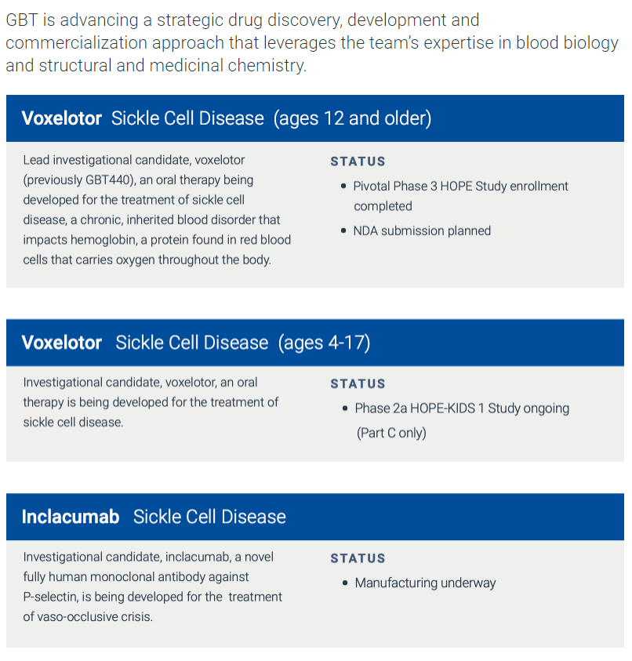

**FINANCIALS**

GBT has Cash $732 M at June 30, 2019, with a quarterly cash burn rate 60 M. This should be sufficient to fund the company next 2.5 years. (2)

**ESTIMATES**

See GBT Excel

**RISKS**

* Voxelotor's failure to obtain FDA approval for SCD and the additional pediatric expansion
* Further dilution. Although the company just executed a public offering, it will most likely need more cash to support manufacturing, marketing, and sales forces need for the launch
* The other concern is if other investigations of voxelotor and inclacumab can generate positive endpoints. If not stock will drop 50% off

**CATALYST**

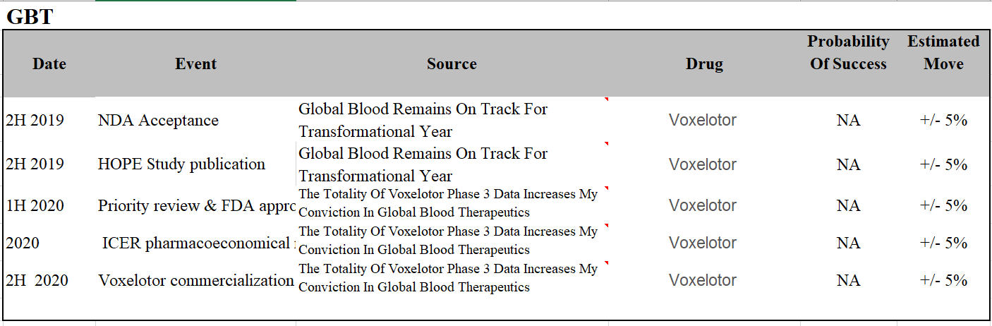

**CONCLUSION / INVESTMENT THESIS**

The run-up in the stock price in 1H 2019, showed the excellent results for voxelotor Phase3 HOPE Study. However, some of the decline in the stock price also seems justified. Given that, the SCD market sits around $3B without a dominant drug like voxelotor, This seems like a good buy given the lack of good treatment options in SCD. (1) Expected to overwhelmingly bullish reaching $80 per share. (3) So I would recommend buy 5% of the Portfolio.

**RESEARCH**

Currently, there is no drug to treat SCD. SCD people Treatments might include medications to reduce pain and prevent complications, and blood transfusions, as well as a bone marrow transplant. Bone marrow transplant for age under 16.

Babies and children age 2 and younger with sickle cell anemia are making frequent visits to a doctor. Children older than 2 and adults with sickle cell anemia see a doctor at least once a year.(4)

**Reference:**

1.https://seekingalpha.com/article/4233354-global-blood-therapeutics-continues-build-strong-case-successful-commercialization

2.https://seekingalpha.com/pr/17597072-gbt-reports-recent-business-progress-second-quarter-2019-financial-results

3.https://seekingalpha.com/news/3471548-analysts-stay-bullish-global-blood-therapeutics-say-selloff-overdone

4.https://www.mayoclinic.org/diseases-conditions/sickle-cell-anemia/diagnosis-treatment/drc-20355882

<https://seekingalpha.com/article/4273643-global-blood-therapeutics-raining-desert-voxelotor>

<https://seekingalpha.com/article/4264205-global-blood-remains-track-transformational-year>