**Office Depot Inc**

Company: Office Depot Inc.

Symbol: ODP

Analysis Date: 8/19/19

Analysis Price: $1.51

Price Target (PT): 1.88$

Upside: 24%

Dividend: $0.0250 (6.62%)

Recommendation: Buy (2%)

Forward PE: 4

Seasonality: Y

**ODP: 1-Year Chart**

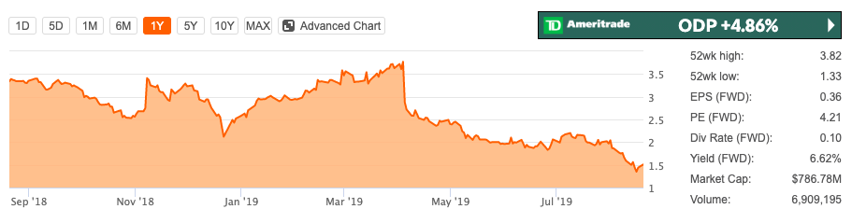

2

1

Source: Seeking Alpha

**CHART ANALYSIS:**

1. April 4 2019 BO. -20%. Revenue report approximately down 2%. Also Approximately $2.76B vs. $2.82B consensus and adjusted operating income of approximately $65M for Q1. The first reason is that the company’s announcement about the disappointing results due to slacking CompuCom segment, which drive to the decline of stock price.
2. May to August 2019. No specific news for decline. The reasons for the stock to decline is probably the lingering affects Q1 news.

**LIQUIDITY POSITION:** Fair

As of 2Q19, ODP had total available liquidity of approximately $1.4B including cash and equivalents of $444M, total current assets of $3.3B, and available credit of 1B With current liabilities of $3.2B, liquidity is not a concern at this time, Cause the remaining $90M authorized for share buybacks, therefore the risk of dilution is quite low. Also they will receive a refund of unutilized AMT credits of $45 million in Q12020. The expected $300M+ of FCF for 2019 comfortably provides for the $50M+ that will be needed to service the dividend

**COMMERCIAL PROSPECTS: Fair**

Since ODP is transforming to B2B services now, B2B sales drove ~90% of operating income in the second quarter. They have three different reporting segment:

**Business Solutions Division**

This segment sells office supplies and related products and services to customers in the US, Customers in the BSD segment are served through a dedicated sales force and catalogs. For 2 Q19, this segment BSD Division Revenue Up 2% as well as net new customer additions.

4/4/2019 8/7/2019

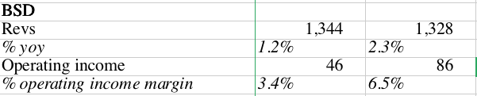

**Retail Division**

ODP’s approximately 1320 retail stores are located in the US, They sell office supplies, technology products, office furniture and also offer business services such as printing, copying, and shipping. sales were down 4% for 2Q19, and driven primarily by lower store traffic.

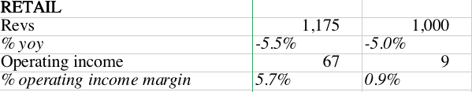

**CompuCom Division**

ODP acquired CompuCom, an IT services provider, in October 2017. The strategic rationale for the acquisition was that ODP would become a one-stop shop for small and medium-sized businesses to have all of their business needs met, from office supplies to IT services. CompuCom Division operating income was $1M 2Q 2019, representing a sequential improvement over the $15 million operating loss in 1Q2019, Even sales were off 7%.

Management is taking steps to address these recent issues, as this segment will feature prominently in ODP’s growing emphasis on being a services provider.

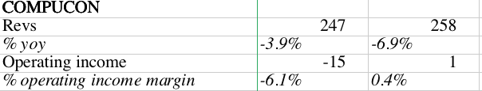

**Estimate:**

See spreadsheet

**Investment Thesis**

Still disappointing results 2 Q19’s results, ODP was clearly not a growth stock. The reason we think it is an attractive buy is because the recent stock price drop dramatically but they still have

adjusted EBITDA over $125M and over $300M in FCF in 2019 to cover its dividends. It will still attract more investors. Also Even upside less !%, but it still has a good dividends. That why I buy the stock.

**FY 2019 Guidance**

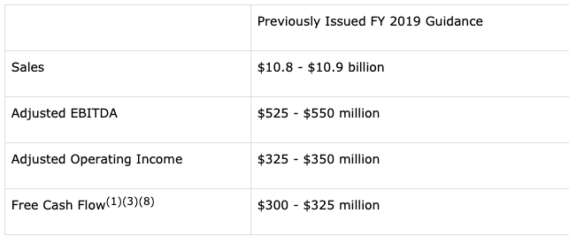

The stock price decline mainly due to the 2019 guidance, sales drop from 11.1B to 10.9 B.