6.I want a list of employees in the east and west regions and I need the full region name, not just the region ID.
proc sql;
create table region as
select
a.employeeregionid,
a.employeelastname,
a.employeefirstname,
b.regionname
from itkm549.employee as a
inner join
itkm549.regionoffice as b
on a.employeeregionid = b.regionid;
quit;
proc sql;
select
*
from region
where regionname = "West" OR regionname = "East";
quit;
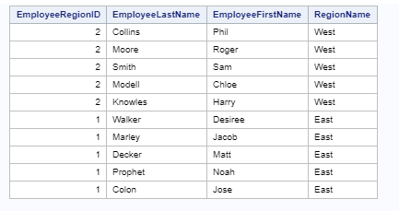
7.I need to know which of our sales reps don’t have any customers, all regions. (Hint: This is adifferent type of JOIN. Also, test for nulls and eliminate the managers.)
proc sql;
create table join as
select
a.employeeid,
a.employeelastname,
a.employeefirstname,
b.customeremployeeownerid,
c.regionname
from itkm549.employee as a
left join itkm549. customer as b
on a.employeeid = b.customeremployeeownerid
inner join
itkm549.regionoffice as c
on a.employeeregionid = c.regionid;
quit;
proc sql;
select
*
from join
where join.customeremployeeownerid is null
;
quit;
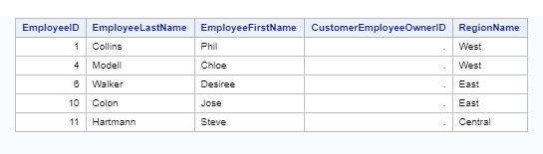
8. Now tell me which region managers are responsible for those sales reps who don’t havecustomers in all regions. Display the region ID, I can get the full name separately. (Hint: You’llneed to see the entire employee/customer list to provide this answer)
proc sql;
create table C as
select
a.employeeid,
a.employeelastname,
a.employeefirstname,
a.employeerole,
b.customeremployeeownerid,
c.regionname,
c.regionid
from itkm549.employee as a
left join itkm549. customer as b
on a.employeeid = b.customeremployeeownerid
inner join
itkm549.regionoffice as c
on a.employeeregionid = c.regionid;
quit;
proc sql;
select
*
from C
where C.employeerole = 'Manager' AND C.customeremployeeownerid is NULL
;
quit;
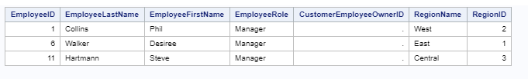

9.Give me the list of customers who have purchased products and the products they purchased.
proc sql;
create table customer_product as
select
a.customerfirstname,
a.customerlastname,
c.productname
from
itkm549.customer as a
inner join
itkm549.productjunction as b
on a.customerid = b. junctioncustomerid
inner join
itkm549.products as c
on c.productid = b.junctionproductid;
quit;

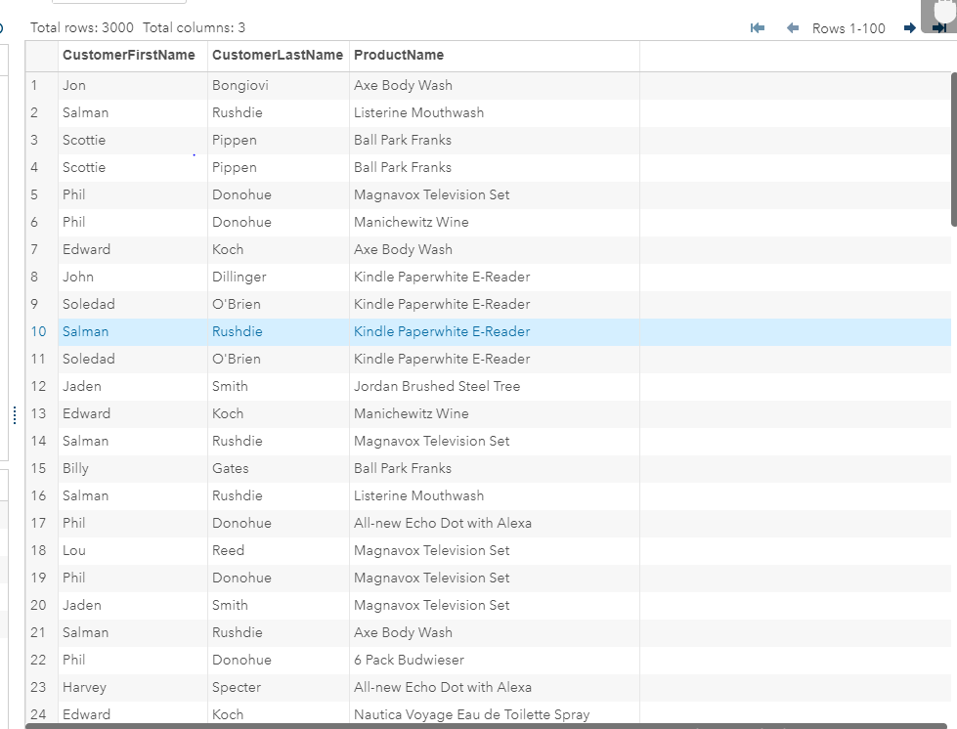
10. Which customers spent more than $75.00? (Hint: Use aggregation and grouping functions).
proc sql;
select
a.customerid,
a.customerlastname,
a.customerfirstname,
sum(c.productunitcost) as total
from itkm549.customer as a
inner join
itkm549.productjunction as b
on a.customerid = b.junctioncustomerid
inner join
itkm549.products as c
on b.junctionproductid = c.productid
group by a.customerid,
a.customerlastname,
a.customerfirstname
having total >= 75.00;
quit;

