1. Provide a list of employees in descending order on last name
proc sql;
select
*
from itkm549.employee
order by employeelastname desc
;
quit;
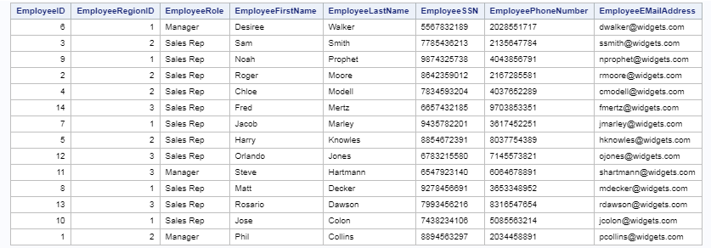

- Tell me the number of unique customers the company has.
proc sql;
select
count (distinct customeremployeeownerid)
from itkm549.customer
;
quit;

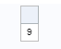

3 Give me a list of all the customers that live in New York.
proc sql;
select
*
from itkm549.customer
where customerstate= 'NY'
;
quit;

4 I need a list of all region managers.
select
employeeregionid, employeerole
from itkm549.employee
where employeerole='Manager'
;
quit;

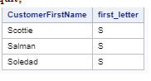

5. Give me a list of customers whose first names start with the letter S
proc sql;
select
customerfirstname,
substr(customerfirstname,1,1) as first_letter
from itkm549.customer
where calculated first_letter = 'S'
;
quit;

