1. Provide a list of employees in descending order on last name.
proc sort data = itkm549.employee;
by descending employeelastname;
run;

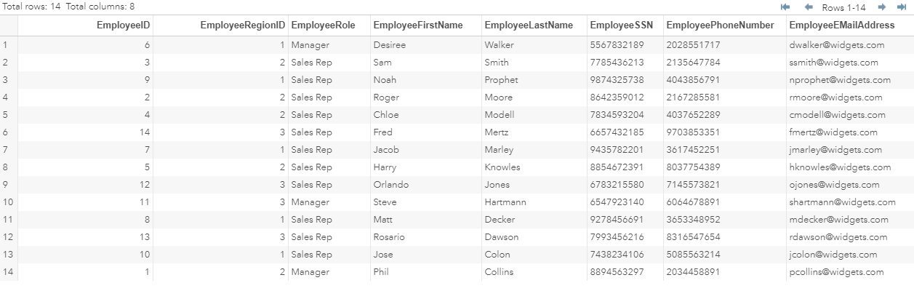
- Tell me the number of unique customers the company has.

3. Give me a list of all the customers that live in New York.
DATA customer_ny ;
SET itkm549.customer;
WHERE customerstate = "NY";
RUN;

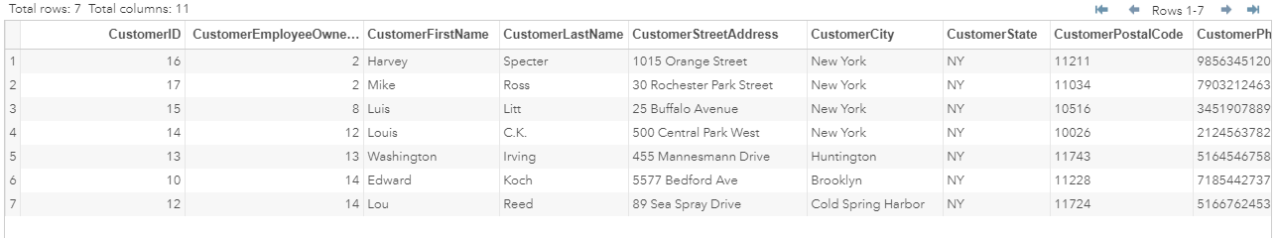

4. I need a list of all region managers.
DATA employee_manager;
SET itkm549.employee;
WHERE employeerole = "Manager";
RUN;
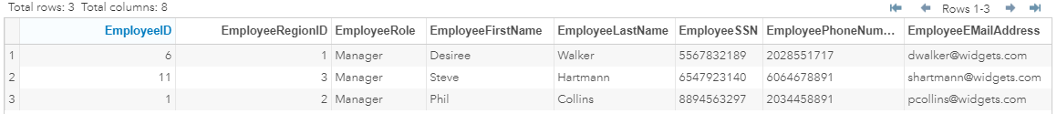

5
5. Give me a list of customers whose first names start with the letter S
Data firstname_S;
SET itkm549.customer;
first_letter = substr(customerfirstname, 1, 1);
run;
data filter_first;
set firstname_S;
where first_letter = 'S';
run;

