6.want a list of employees in the east and west regions and I need the full region name, not
just the region ID.
proc sort data = itkm549.employee;
by employeeregionid;
run;
proc sort data = itkm549.regionoffice;
by regionid;
run;
data inner_join;
merge itkm549.employee (rename = ( employeeregionid = Regionid ) in = c)
itkm549.regionoffice (in = e);
by regionid;
if e = 1 and c = 1 then output;
run;
data work.east_west;
set work.inner_join;
keep employeeid employeefirstname employeelastname regionname regionid;
where regionname ="West" or regionname = "East";
run;

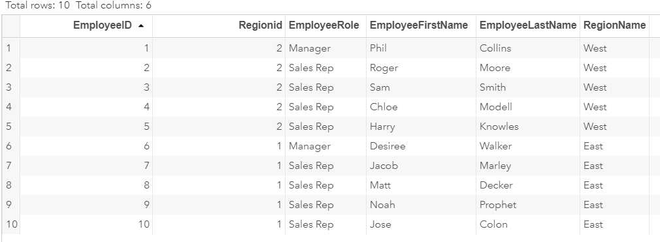

7. I need to know which of our sales reps don’t have any customers, all regions. (Hint: This is a
different type of JOIN. Also, test for nulls and eliminate the managers.)
proc sort data = itkm549.customer;
by customeremployeeownerid;
run;
data right_join;
merge itkm549.customer (rename = (customeremployeeownerid = employeeid) in = c)
itkm549.employee ( in = e);
by employeeid;
if e then output;
run;
proc sort data = work.right_join;
by employeeregionid;
run;
data full_join1;
merge work.right_join (rename = (employeeregionid = regionid) in = h)
itkm549.regionoffice;
by regionid;
run;
data no_customer;
set work.full_join1;
keep customerid employeeid employeerole employeefirstname employeelastname regionid regionname;
where employeerole = "Sales Rep" and customerid = .;
drop customerid;
run;
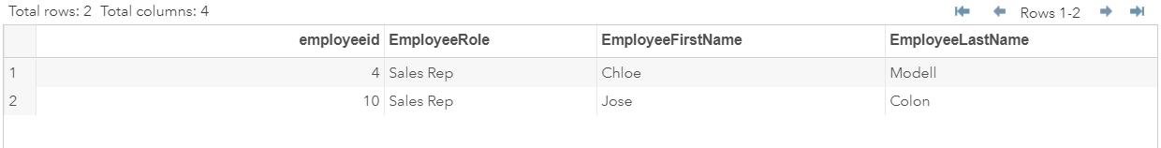

8. Now tell me which region managers are responsible for those sales reps who don’t have
customers in all regions. Display the region ID, I can get the full name separately. (Hint: You’ll
need to see the entire employee/customer list to provide this answer)
data manger_employee'
proc sort data = work.inner_join;
by employeeid;
run;
proc sort data = work.right_join;
by employeeid;
run;

data full_join;
merge work.inner_join (in = c)
work.right_join ( in = e);
by employeeid;
run;

data manager_employee;
set full_join;
keep customerid employeeid regionid employeerole employeefirstname employeelastname regionname;
where customerid = .;
drop customerid;
where employeerole = "Manager"
and regionid <3;
run;

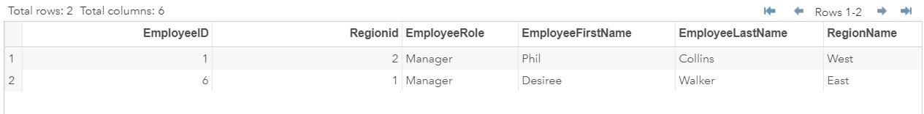

9. Give me the list of customers who have purchased products and the products they
purchased.
proc sort data = itkm549.customer;
by customerid;
run;
proc sort data = itkm549.products;
by productid;
run;
proc sort data = itkm549.productjunction;
by junctionproductid;
run;
proc sort data = itkm549.productjunction;
by junctioncustomerid;
run;
data inner_joinpurchase;
merge itkm549.customer (rename = (customerid = junctioncustomerid) in = j)
itkm549.productjunction (in = k);
by junctioncustomerid;
if j = 1 and k =1 then output;
run;
data inner_joinpurchase2;
merge itkm549.products (rename = (productid = junctionproductid) in = j)
itkm549.productjunction (in = k);
by junctionproductid;
if j =1 and k = 1 then output;
run;
proc sort data = work.inner_joinpurchase;
by junctionid;
run;
proc sort data = work.inner_joinpurchase2;
by junctionid;
run;
data inner_joincustomerproduct;
merger work.inner_joinpurchase (in = a)
work.inner_joinpurchase2 (in = b);
by junctionid;
if a = 1 and b = 1 then output;
keep customerfirstname customerlastname productname;
run;

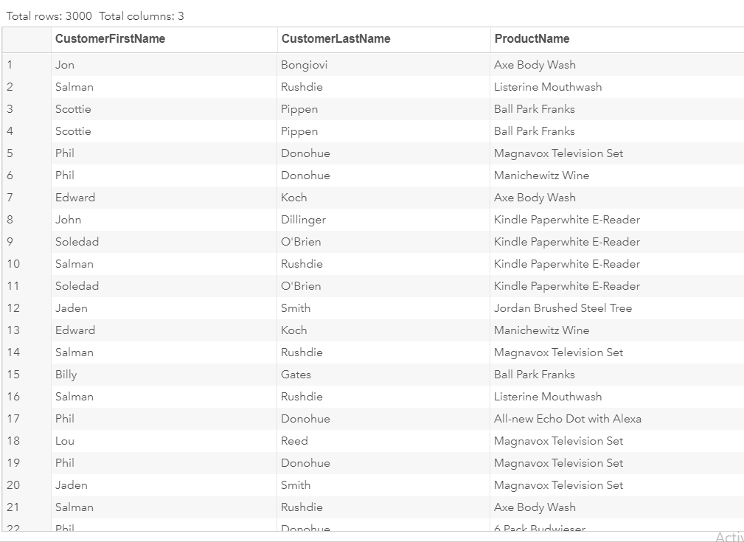

10. Which customers spent more than $75.00? (Hint: Use aggregation and grouping functions)
proc sort data = work.inner_joincustomerproduct3;
by junctioncustomerid;
run;
proc summary data =inner_joincustomerproduct3;
by junctioncustomerid;
var productunitcost;
output out=sum sum = sum n;
run;
data sumary_product;
merge itkm549.customer
sum;
keep customerid customerfirstname customerlastname sum;
if sum > 75 then output;
run;

