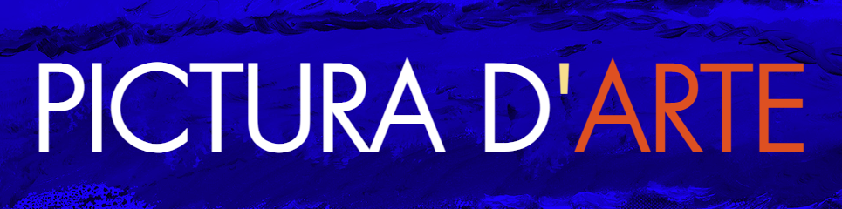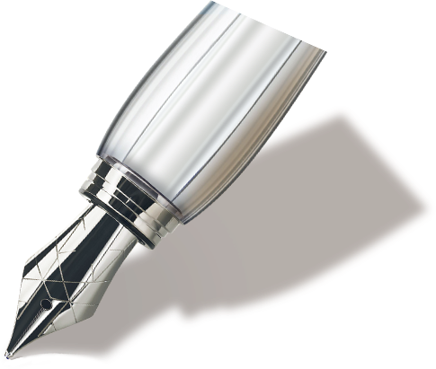

**Thanks for your Order**

Dear Peipei,

Please find attached you requested Digital file in PDF format for printing in a format of 11 x 17”. We can provide you with additional file for larger format. Thank you for your purchase.

Link:

[https://www.dropbox.com/s/1h7rk1ko2ucfeyq/0002%20JBD%20OIL%20ON%20CANVAS%2036%20X%2024%202019%20FAIRFIELD%20USA%20THE%20BUCKETS%20ST%20BARTH.pdf?dl=0](https://www.dropbox.com/s/1h7rk1ko2ucfeyq/0002 JBD OIL ON CANVAS 36 X 24 2019 FAIRFIELD USA THE BUCKETS ST BARTH.pdf?dl=0" \t "https://mail.google.com/mail/u/1/" \l "inbox/_blank)

Sincerely,

PicturaD’arte Sales Team

Please copy and paste this link into your web browser to access the PDF artwork file

JB handwriting name

CEO XXXX