The Analysis Toolpak is an Excel program that is available when you install Microsoft Office or Excel using PC.

For PC, to use it in Excel, however, you need to load it first.

1. On the Star up menu, click Excel Options.
2. In the Excel Options, click Add-Ins.
3. Click to highlight the “Analysis Toolpak”, and then click GO.

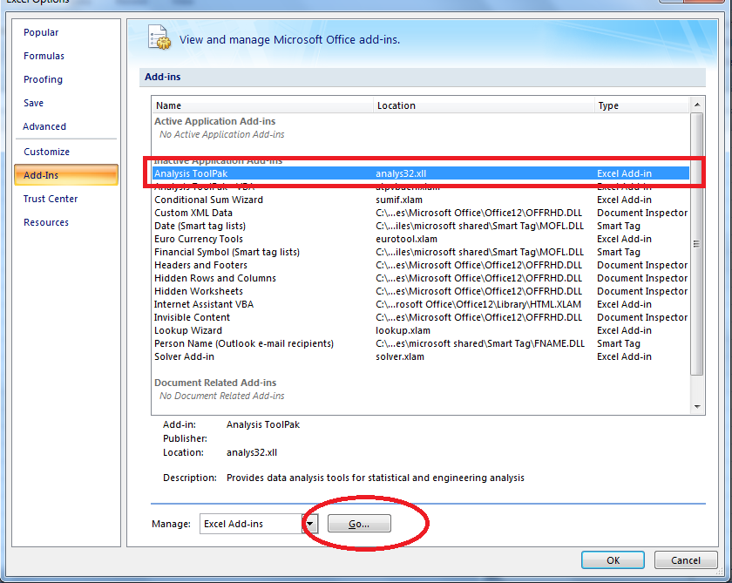

1. Check the Analysis Toolpak and Solver Add-in, then click OK.

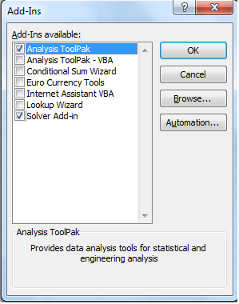

For Mac, please visit <http://support.microsoft.com/kb/914208>, If you are using Excel 2011 or older version, you need to download the free StatPlus software and install it, <https://support.microsoft.com/en-us/kb/2431349>, and download StatPlus from <http://www.analystsoft.com/en/products/statplusmacle/>

When you use StatPlus, the "Dependent Variable" is stock risk premium, the "Independent Variable" is market risk premium.

For Mac, if you use Excel 2016 or later version, very simple:

1. On the Tools menu, select Add-Ins.
2. In the Add-Ins available box, select the Solver Add-In check box, and then click OK. ...
3. After you load the Solver add-in, the Solver button is available on the Data tab.