Project I: Optimal Risky Portfolio
- Download data for CA and US (25% credit)
Step 1: Go to https://www.msci.com/end-of-day-data-country
Step 2: Choose All Cap for Size, click SEARCH, then scroll down to find US
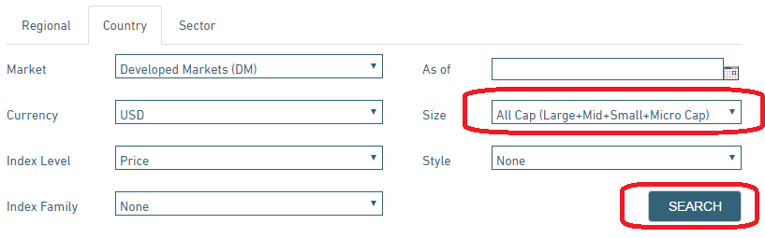
Step 3: When choosing data for a country, select Full History, and Monthly, click Update, then download data. (You must enable FLASH to see the content)
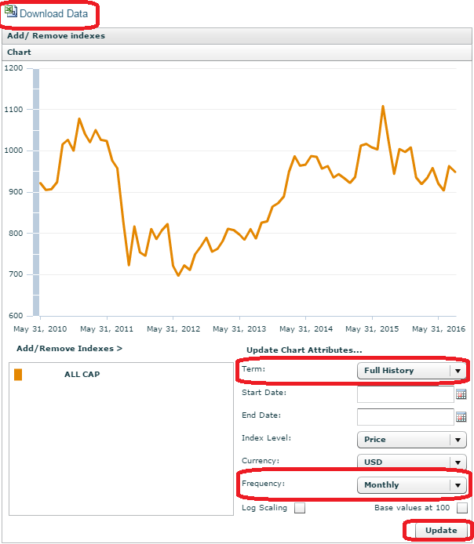
- In the data file, get each country’s monthly excess return (or risk premium which is raw return subtracts risk free rate) and calculate its arithmetic mean (average monthly excess return). Then get the covariance matrix among 23 country excess returns. In the Solver template file, fill in the equations in cells from D58 to Z58 based on Standard Deviation Formula. (25% credit)
- Assume now is the end of year 2020, use the global equity data and Excel Solver to solve the weight (without short-sell, which mean no borrowing) for each country in a global diversified portfolio. These weights will guide you how to allocate your money in each country in January 2021. Report all these weights for all countries as well as the Optimal Risky portfolio’s expected excess return, standard deviation, and Sharpe ratio. (25% credit)
- Solve the weight allowing for short-sell for each country in a global diversified portfolio. Report all these weights for all countries as well as the Optimal Risky portfolio’s expected excess return, standard deviation, and Sharpe ratio. (25% credit)
Note that you need to use Covariance function in Excel under “Data Analysis” based on Excess Returns. All detail calculations and Excel work must be presented.

Legend for your data:
AU—Australia, HK—Hong Kong, JA—Japan, NZ—New Zealand, SI—Singapore, AS—Austria, BE—Belgium, DE—Denmark, FI—Finland, FR—France, GE—Germany, IS-Israel, IR—Ireland, IT—Italy, NL—Netherlands, NW—Norway, PO—Portugal, SP—Spain, SW—Sweden, SZ—Switzerland, UK—United Kingdom, CA—Canada, and US—United States. Monthly3MTB—Monthly 3-month T-Bill rate. RP—risk premium.

