Project II for FNCE6540—Equity Intrinsic Price

Part I—Verify the Beta
- You are assigned a stock. Please check Page 3 for your stock ticker.

- Print screen (“Ctrl”+ “prt sc”) the key statistics page on Yahoo!Finance. Stock ticker, trading price, Beta and computer system time must show on the print screen picture. For example:

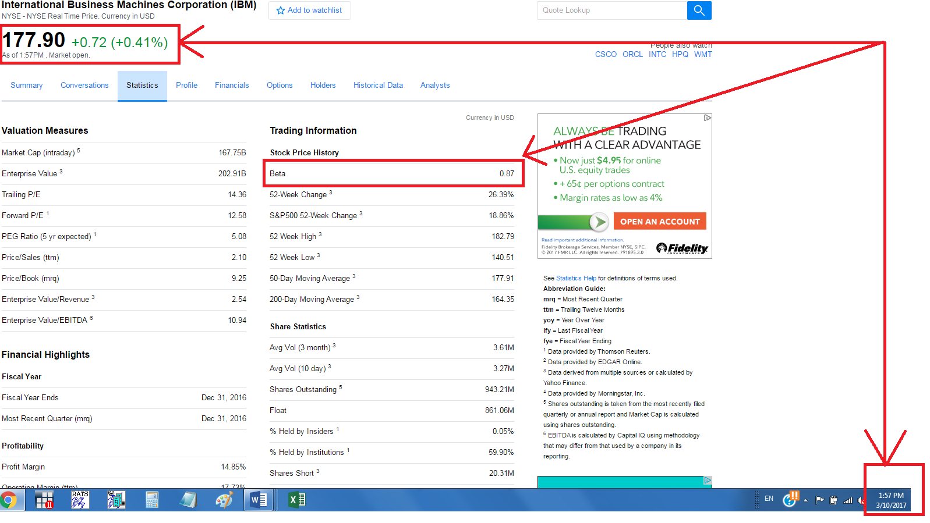
- Download historical prices of your stock (see last page) on Yahoo!Finance, using monthly prices in the past 61 months. Calculate the past 60 month (5-year) stock returns.

- Download historical prices of the S&P500 index on Yahoo!Finance, using monthly prices in the past 61 months (not including current month) same as the stock. Calculate the past 60 month(5-year) market returns.
http://finance.yahoo.com/q/hp?s=SPY+Historical+Prices

- Download 1-month risk-free rate in the past 60 months same as the stock and S&P500. http://research.stlouisfed.org/fred2/series/TB4WK/downloaddata
Note that the interest rate is in percentage format and annualized, need to divide it by 100 and then further divide it by 12 to get the monthly risk-free rate.
- Merge these three data files by months. Generate stock risk premium column and S&P500 risk premium column.
- Run a simple linear regression based on stock risk premium and S&P500 risk premium to verify the Beta reported in Yahoo!Finance which is shown on your print screen picture (your result could be slightly different from Yahoo’s Beta). You must present the regression output in Excel.
Part II—Estimate the intrinsic price and make an investment decision.

- Print screen (Ctrl+prt sc) the key statistics page on Yahoo!Finance. stock ticker, trading price, Beta, Return on Equity, Trailing Annual Dividend Rate, Payout Ratio must show on the print screen picture (numbers must be readable on the picture). For example:
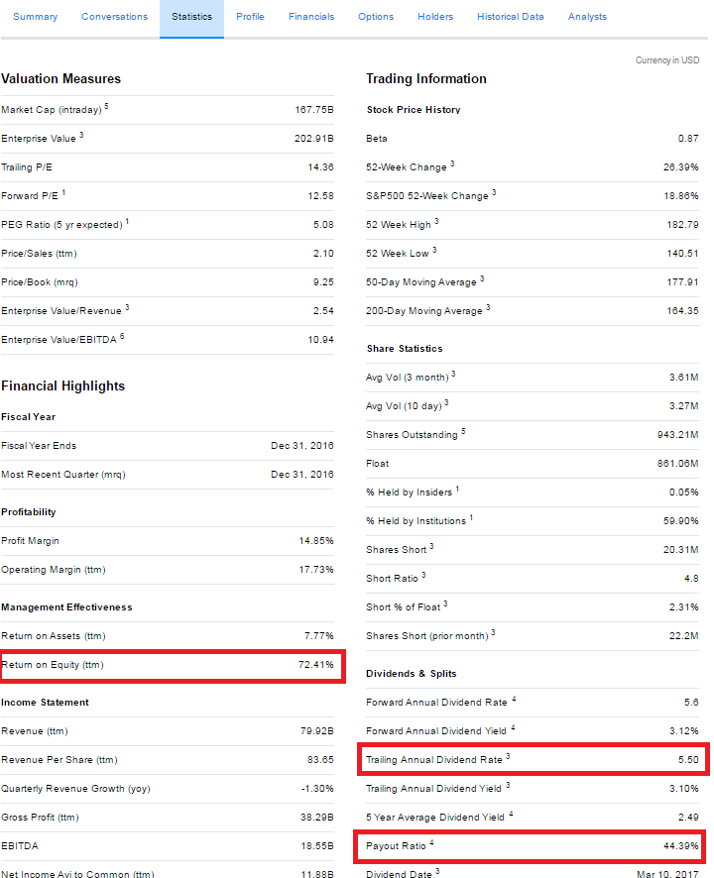

- Based on above stock information and Dividend Discount Model (DDM), calculate the intrinsic price of the stock given the expected S&P500 return is 20% and risk free rate is 1% (hint: expected market risk premium is 20%-1%=19%). Use the beta you calculated in the previous step. Detailed calculation must be presented.

- Make an investment decision (buy, hold, sell, short sell, call option, and/or put option) based on the stock’s trading price and your intrinsic price.

- What is the trailing P/E of the stock? According to the trailing P/E, is the stock overvalued, undervalued, or fairly priced? Is your DDM investment decision from the above question in line with your investment decision based on P/E?

